**Keep America Beautiful**



**Cougar Student Technologies**

**Alex Garcia, Arianna Camino, James Hanlon, Oscar Castellanos, Vinny Vue**

**Table of Contents**

**Executive Summary** **3**

**Application Development** **4**

Business Context 4

Project Proposal 4

Requirements Matrix 7

**Project Management** **9**

Product Breakdown Structure 9

Work Breakdown Structure 10

Gantt Chart 11

Cost Tracking Chart 14

**Team Information** **15**

Team Resumes 17

**Group Timesheets** **23**

## 

### Executive Summary

#### 

**Date** : 5/17/2021

**To** : Dr. Wesley Schultz

**Cc** : Dr. Shaun-Inn Wu, Director of Projects

**From**: Oscar Castellanos, Cougar Student Technologies Team

**RE**  :Phase #5; Final Product

**Overview**

In Phase 4 we successfully created a script that queries an input for a city or for a defined location. With OSMnx we are able to retrieve 4 Google Street View images from one coordinate point within OSMnx. We are able to do this by rotating 90 degrees at each coordinate point. Metadata is clearly outputted with the date of which the photo was taken, latitude and longitude, the image ID and the status of the requested image. Both the image and metadata are saved to a specified folder.

**To improve/continue:**

With the foundation of what Cougar Student Technologies built using OSMnx within python, there are always areas for improvement. We would like to implement these so the user has more ease of access as well as simpler results. The first is to build an easy user interface. This would allow the user to only see what inputs they can enter such as city/town, or coordinates around a certain area. Once all the information is entered it would display the OSMnx graph, all the information it gathered and state where the files/images have been saved. The next step would be to connect our OSMnx python script to the previous group's Machine Learning algorithm that is stored on AWS. Pulling images from our python script and saving them to then be pulled into the algorithm is going to be a hard task to implement. Once this is completed then using other groups designs of how trash/litter is tracked can be determined.

**Time and Cost:**

The time and cost of the fourth phase between a team of five CST members has totaled 104 hours at a rate of $25.00/hour, yielding a total amount of $2,600. The remaining phase will be projected to cost $2,400. The total cost of the project approximates to $11,950 and is subject to change as we continue working on the project.

Enclosed: Final Report

_________________________________________ __________

Dr. Wesley Schultz, Acceptance Print & Signature Date

### 

### **Application Development**

#### **Business Context**

Keep America Beautiful is a non-profit organization that aims to end littering, improve recycling and beautify communities through various programs and initiatives. The organization is supported by community-based affiliates, volunteers, corporate partners, municipalities, and elected officials. Previous partners have worked with Google Street View Static API for pulling Google street images using python scripts.

**Business Problem**

Keep America Beautiful is seeking for a solution to obtain images from Google Street View to be processed by an algorithm that identifies litter. They also require the solution to be automated to allow for larger scalability and efficiency.

#### **Project Proposal**

Our team will create a system for pulling these Google street images for a designated area given the city, region, community, county, etc. The objective is to design a program that will automate the process of obtaining images for detecting litter. So that once the system has been developed, we can then pass these images through the ML algorithm to get their litter scores.

**Deliverables**

* The client should expect to receive a word document report of the prototype in their email inbox.
* A downloadable zip file folder with descriptive files..
* A link to our github for the entire project which will include:
  + The program used to define locations and request images from Google Street View.
  + A manual with instructions on how to run the program.
  + All documentation and reports throughout the project.

**Measures of Success**

Phase 1:

* Identify the project requirements and needs from the client and report the Meeting Minutes back to understand what we need to accomplish.
* Ask many questions to understand and define what is expected from the project.

Phase 2:

* Finalize project requirements and needs from client. Meeting JAD 2 with the client and director to finalize questions, confusion, must haves and nice to haves.
* Understanding the exact requirements from the client is essential to beginning our prototype 1. Our prototype 1 we will begin looking at many different ways Street View Images can be extracted.

Phase 3:

* From the project requirements, we were able to design a simple automated program to request an image of a single location from Google Street View.
* Save the image and metadata into a specified directory on our local hard drive.
* Able to deliver a basic script in Python to our GitHub repository, so the following teams can see our progress and continue to improve it.

Phase 4:

* Improve the original program by requesting multiple images of a single location.
* Implement OSMnx into the program to obtain various locations and regions that the user would like to extract images from.
* Allow inputs to obtain coordinates from a city or a specific location with a defined radius.
* Python script has been updated in GitHub and can be accessed via JupyterLab.
* We will create a user friendly guide and runthrough of how to install and run OSMnx with our python script.

Phase 5:

* A deployable prototype the client can readily use with various input options.
* A presentation of the final project with outcomes and report findings.
* Future implementation suggestions and manuals to provide groups after us who would like to utilize the script.

**Visual Representation**

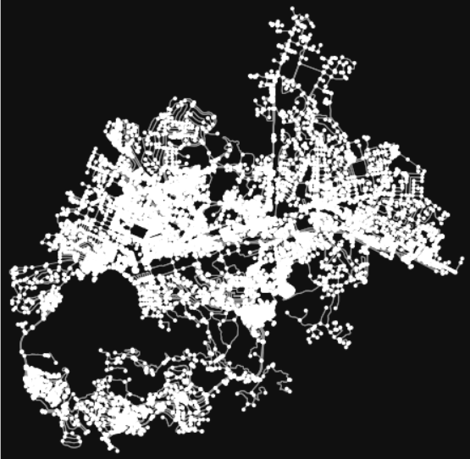

*OSMnx detecting streets with node points in San Marcos, CA.*

OSMnx was a great tool to use to retrieve metadata about multiple nodes that we could potentially feed into our image and data retrieval system to retrieve an image . The challenge was that it limited the amount of data we could extract because OSMnx primarily provides vertice coordinates such as street intersections. Despite the limitations, OSMnx still provides the system many coordinate pairings which can be used for further analysis.

#### 

#### Requirements Matrix

|  |  |  |  |  |
| --- | --- | --- | --- | --- |
| **Req. #** | **Requirement** | **Description** | **Task #** | **Implemented** |
| 1 | User requested location with a fixed boundary | * A user defined location will help restrict the number of extracted images. * A user input will determine the distance of the search boundaries. | 65 | Yes |
| 2 | Collect  Google Street View images | * Obtain and download Google street images to a specified folder. The script will execute to request Google images. | 66 | Yes |
| 3 | Collect  Metadata | * Obtain and download metadata from each photo rendered from the Google street images. | 83 | Yes |
| 4 | Use OSMnx to obtain coordinates | * Use OSMnx to define coordinates within a location to easily grab latitude and longitude points for the script to request the image. | 84 | Yes |
| 5 | Obtain 4 images from each location | * For each coordinate, rotate the field-of-view by 90o to retrieve an image in each cardinal direction. | 86 | Yes |

### 

**Nice-to-Have Matrix**

### 

|  |  |  |  |  |
| --- | --- | --- | --- | --- |
| **Req#** | **Nice to have** | **Description** | **Task #** | **Implemented** |
| 1 | Easy User Interface | * Create an interface so that users that are not familiar with code can utilize the script as a tool. * Navigation bar and display of results. | 97 | No |
| 2 | Connecting OSMnx to previous group ML | * Contact previous groups to access AWS ML Algorithm * Run instances and figure out how to connect OSMnx data and output onto the ML algorithm | 98 | No |
| 3 | Allow a random sampling | * Allow the user to define if they want a number of random samples from the initial list of coordinates | 99 | No |

### 

### 

### **Project Management**

#### 

#### Product Breakdown Structure

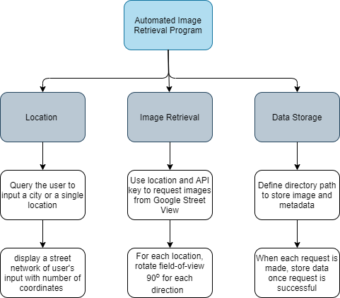

#### Work Breakdown Structure

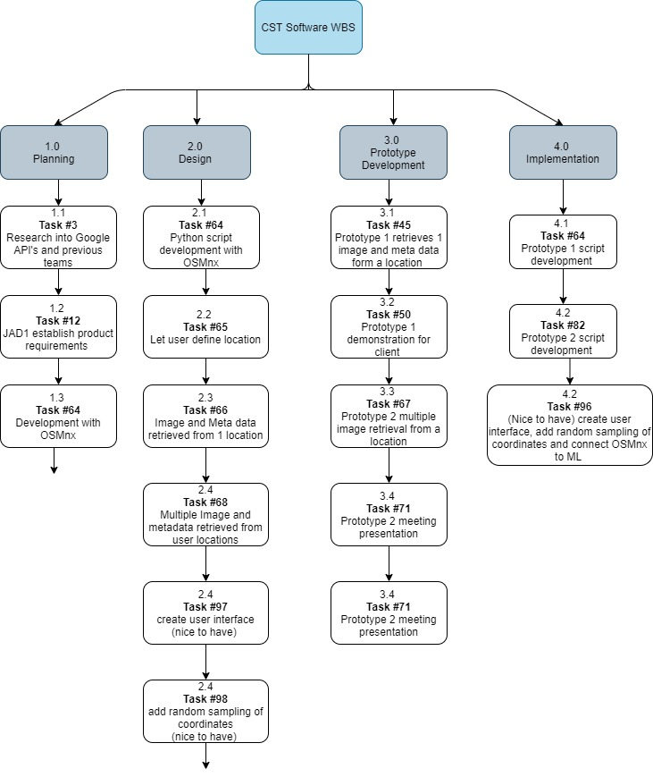

#### **Gantt Chart**

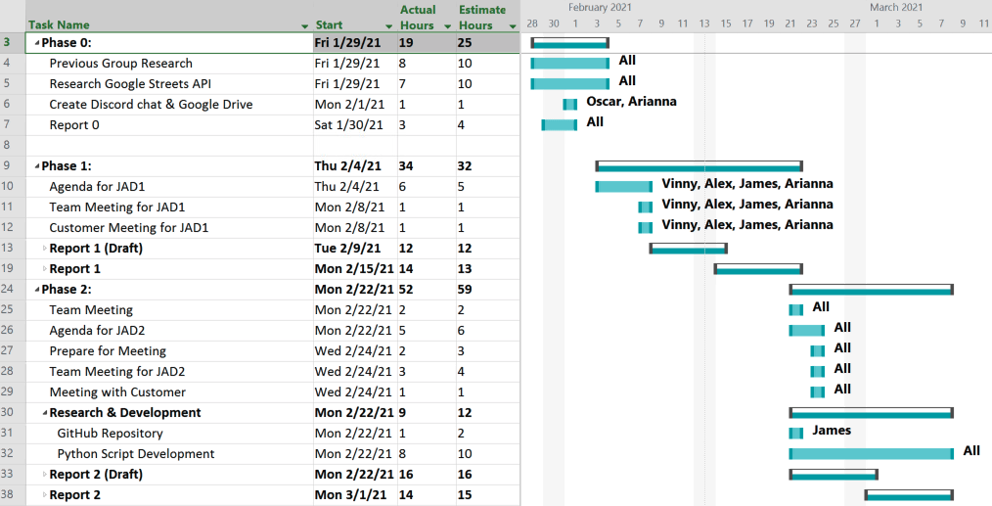

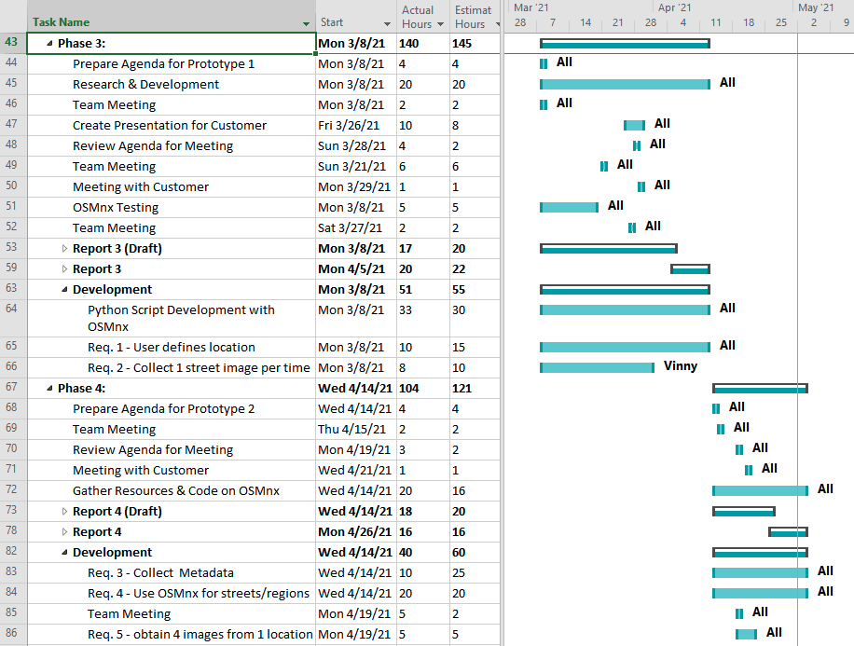

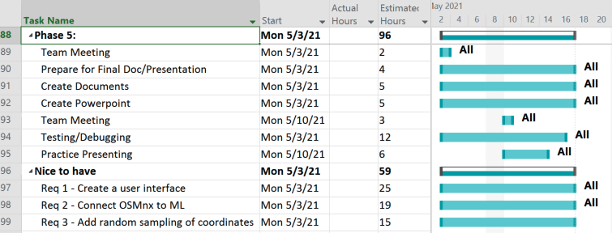

#### 

#### **Cost Tracking Chart**

We will assume an hourly rate of $25.00 per hour for this project. We assessed that this rate is appropriate for the project scope and requirements but is negotiable with the client if desired. Below is a chart outlining estimated and actual costs for each phase of the project as well as our total accumulated costs compared to our estimated costs. All values are represented in dollars.

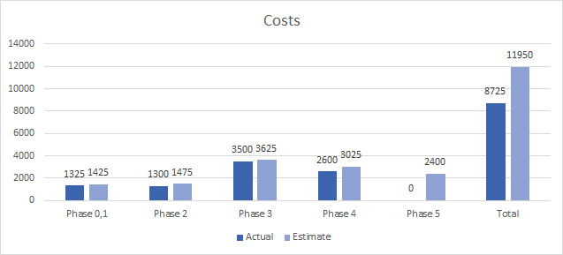

**Resources**

Our team will be supplying the following resources for this project:

* Our work and research into previous team projects and additional resources used.
* All images collected for the project.
* An updated document for each phase of the project.
* A final report detailing our process and updates throughout the project.

Our team will need to be supplied the following resources from the client:

* Reports from previous teams for reference
* Approval on our project solutions
* Future meeting availability

### **Team Information**

As a team, we expect to have all team members contribute knowledge, opinions, and time consistently to fulfill weekly goals throughout the life of the project. Team members will conduct themselves professionally, respectfully, and cordially among each other and with Dr. Schultz. Collaboration among all team members will play a key role in the team’s success.

|  |  |
| --- | --- |
|  | **Oscar Castellanos**  Project Leader  Cell: 760-693-6704  Email: Caste055@cougars.csusm.edu  **Experience**: Experience leading previous groups and managing a team! |
|  | **James Hanlon**  Project Manager  Cell: 760-330-1910  Email: Hanlo007@cougars.csusm.edu  **Experience**: Familiar with Google Maps and Street View but no experience implementing API’s. Very good communicator, have led students and children for many years with previous roles. Can resolve issues and conflicts if they arise, as well as identify the end result the customer desires. |
|  | **Arianna Camino**  Multimedia Programmer  Cell: 760-497-5890  Email: Camin003@cougars.csusm.edu  **Experience**: No previous experience with machine learning or Google Maps API, some experience with AWS and databases, plenty experience communicating and working with groups of all kinds. |
|  | **Alex Garcia**  Documentation & Training  Cell: 951-358-2990  Email: Garci825@cougars.csusm.edu  **Experience**: No experience or background in Google Map API, machine learning, or Python. Experience in collaborating with others in achieving the best possible outcome of any project or service. |
|  | **Vinny Vue**  Programmer/Database Administrator  Cell: 858-245-0618  Email: vue003@cougars.csusm.edu  **Experience**: No previous experience with Google Map API or machine learning. Familiar with programming languages and web design along with databases. As well as working and collaborating in a team environment. |

#### Team Resumes

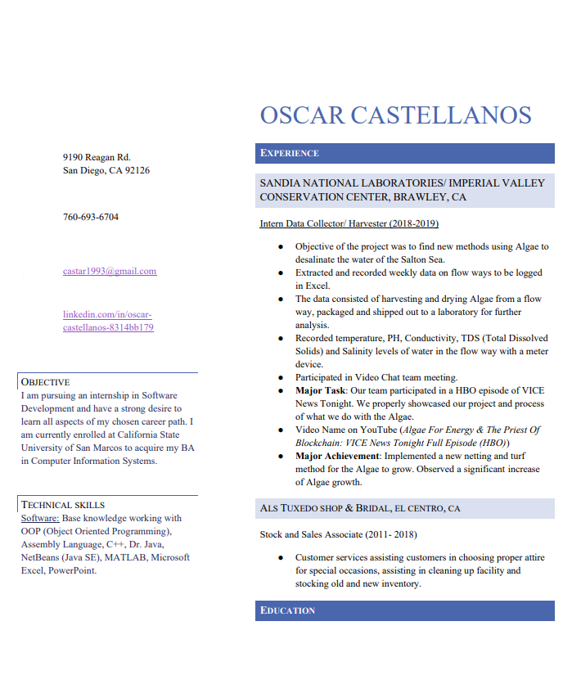

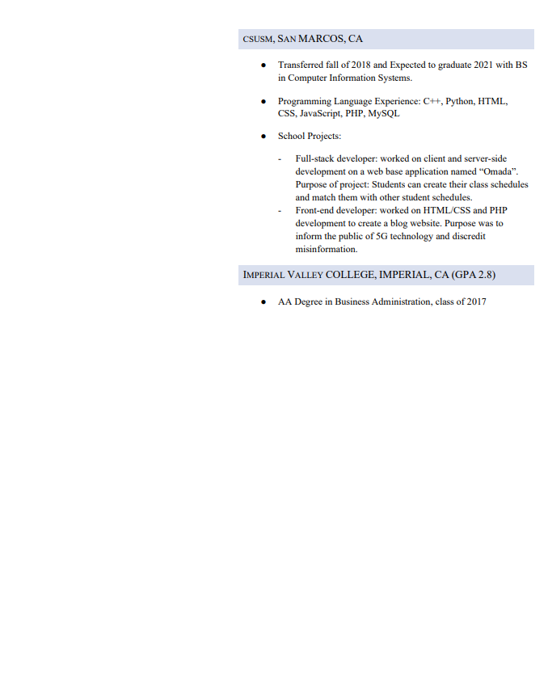

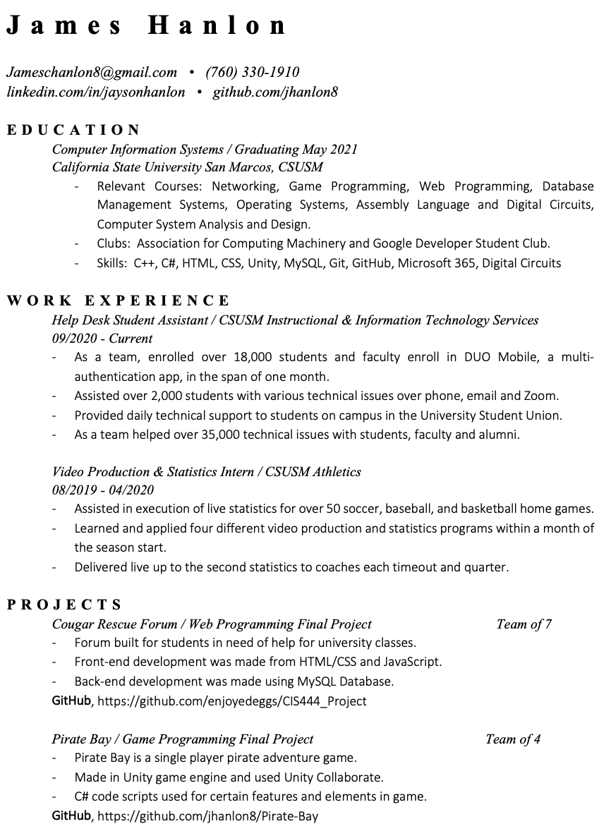

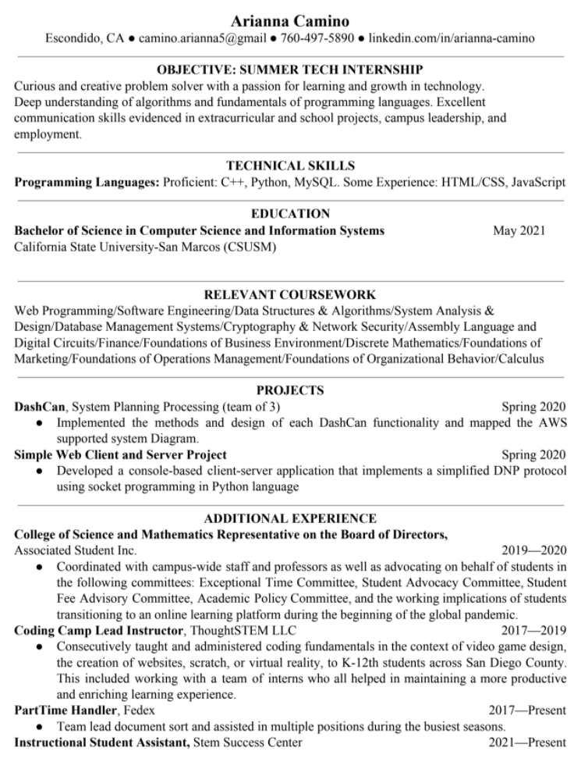

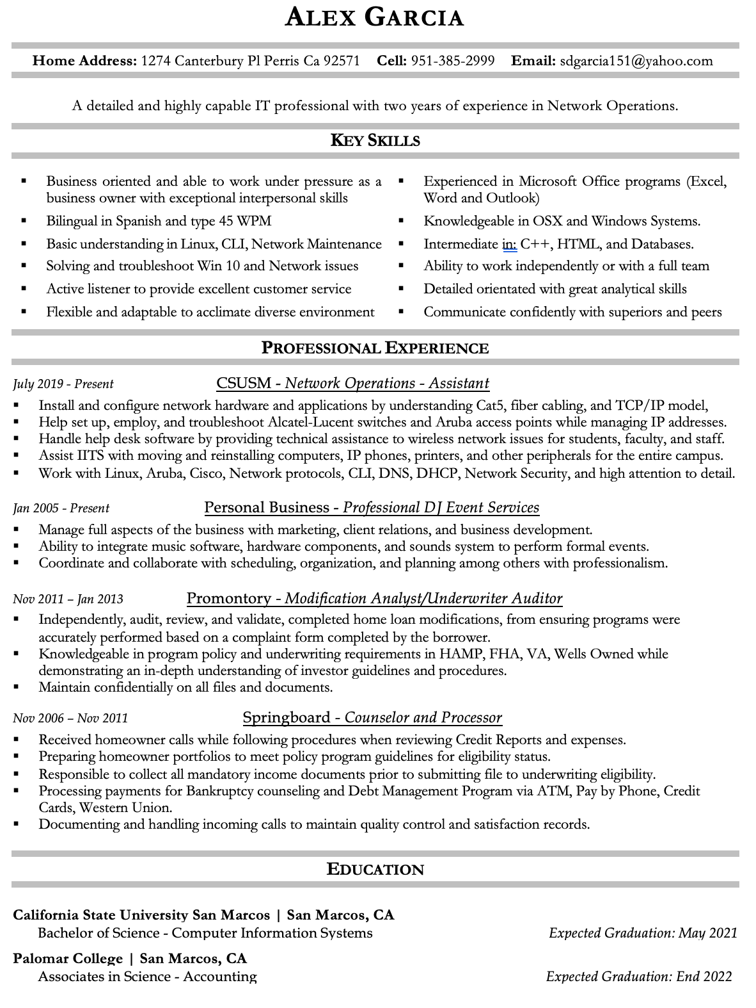

#### 

#### 

### Group Timesheets

**Oscar Castellanos:**

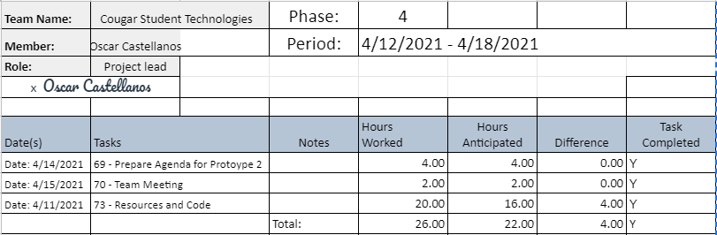

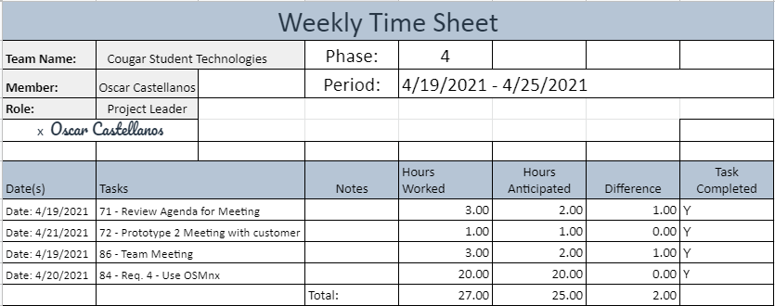

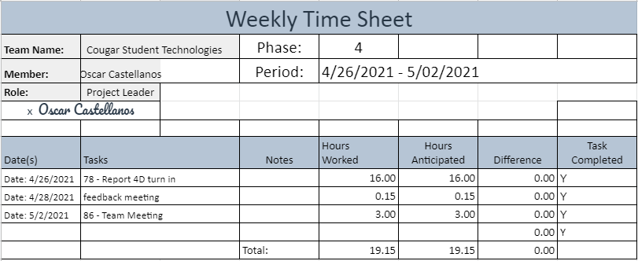

**James Hanlon:**

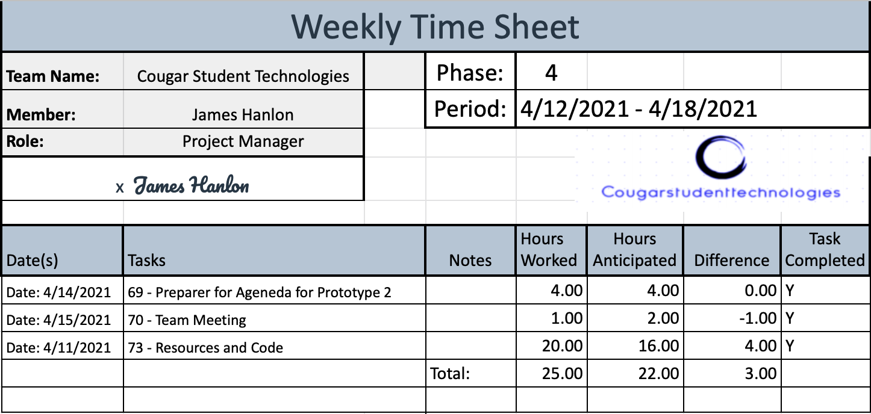

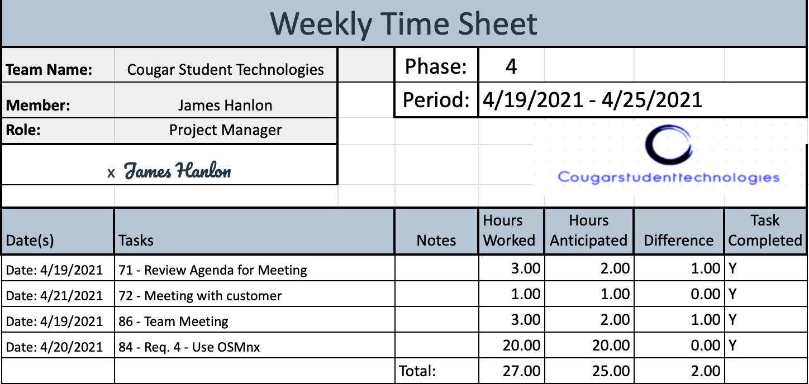

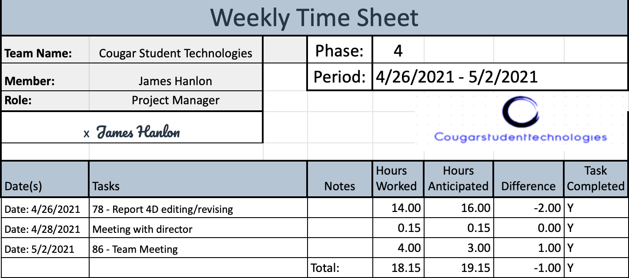

**Arianna Camino**

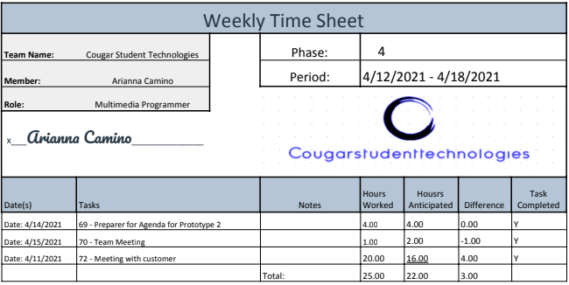

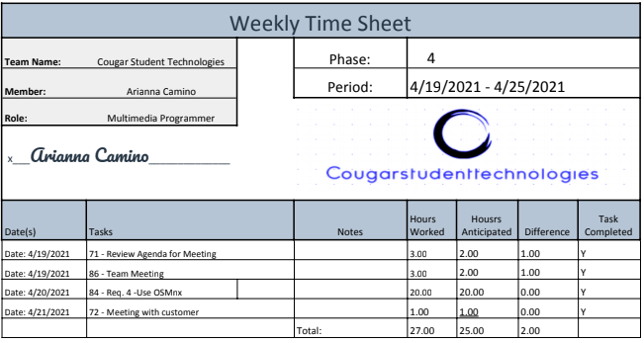

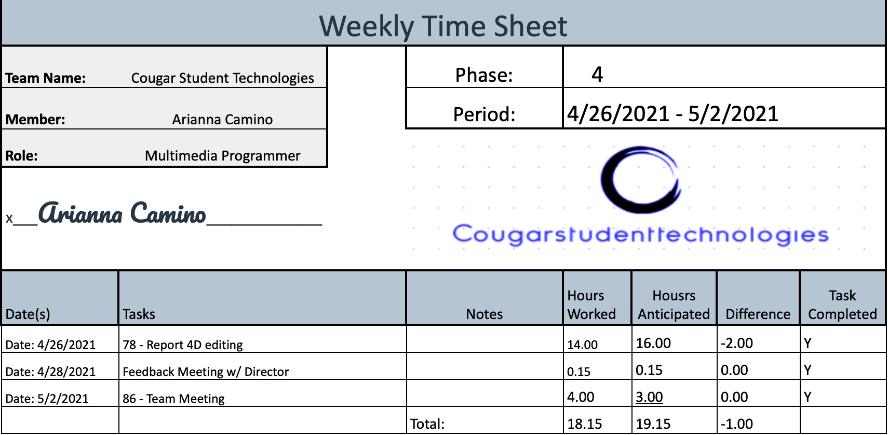

**Vinny Vue:**

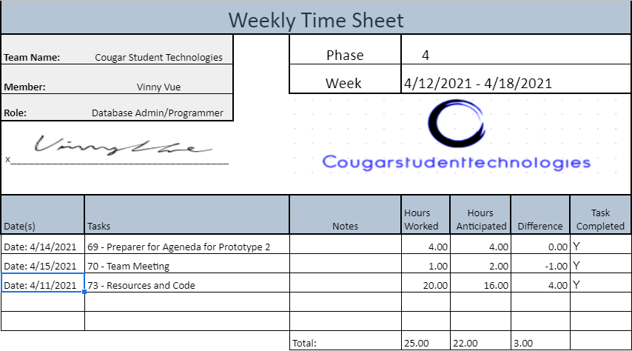

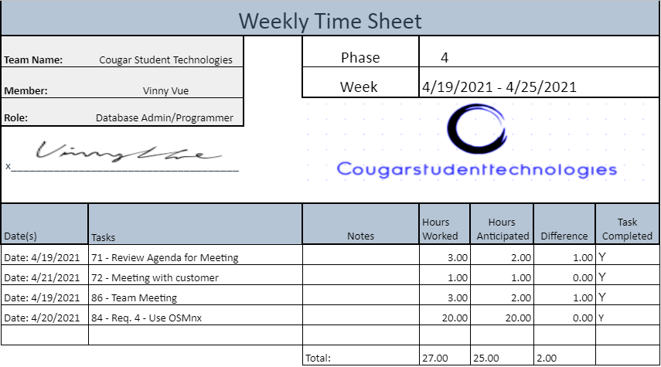

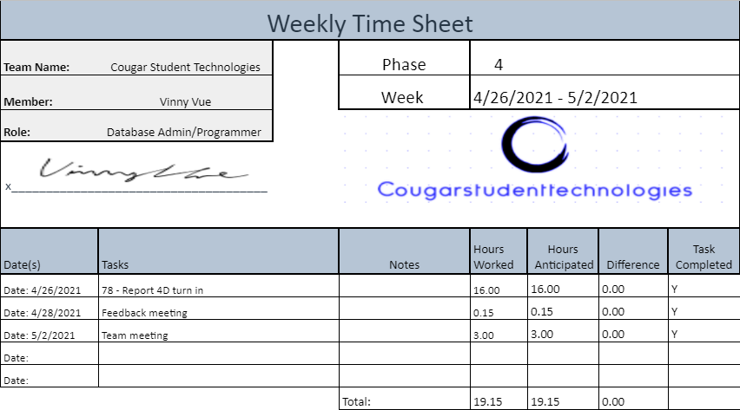

[Alex Garcia](mailto:garci825@cougars.csusm.edu):

